**SQL PROJECT – HIRING ABC COMPANY (Real Question)**   
  
**Read the Task Very minutely for all test cases to pass :   
  
STRICTLY NO COPY PASTE FROM GOOGLE**   
  
Create the following table structure in SNOWFLAKE by creating your own warehouse. Insert some 10 rows using INSERT command (check task 3 and same way insert for all task tables) in the table by trying different values for all the columns and then check using SELECT * Once data is loaded, performed the below task  
  
**(Notes :- My snowflake UI is ‘Snowsight’ Since I’ve seen some difference while running querries in ‘classic UI’ and ‘Snowsight’)**

Task - 1

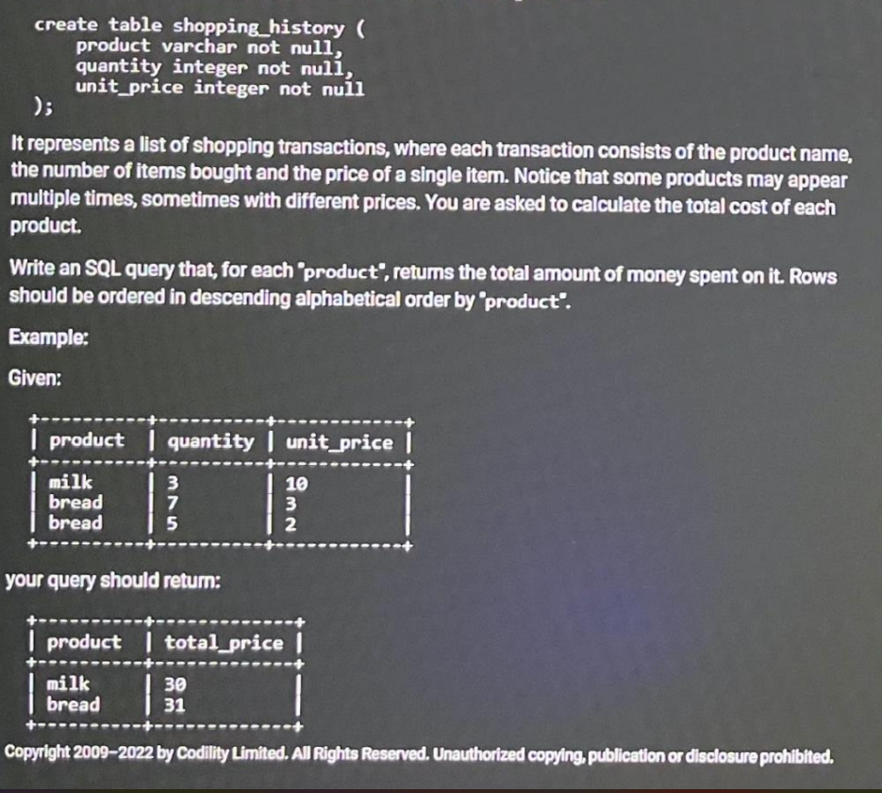

Create database HB_HIRING_ABC_COMPANY;

use HB_HIRING_ABC_COMPANY;

drop table shopping_history;

create table shopping_History (

Product Varchar(30) not null,

quantity integer not null,

unit_Price integer not null);

insert into shopping_History(Product,quantity,unit_Price) values('milk',3,10);

insert into shopping_History(Product,quantity,unit_Price) values('bread',7,3),

('bread',5,2),

('egg',10,2),

('chocolate',15,5),

('chocolate',10,4),

('maggi',20,5),

('chips',10,2),

('chips',10,3),

('toffee',20,1);

**select * from shopping_history;**

**select product, sum(quantity * UNIT_PRICE) as Total_Cost from SHOPPING_HISTORY**

**group by product**

**Order by product desc ;**

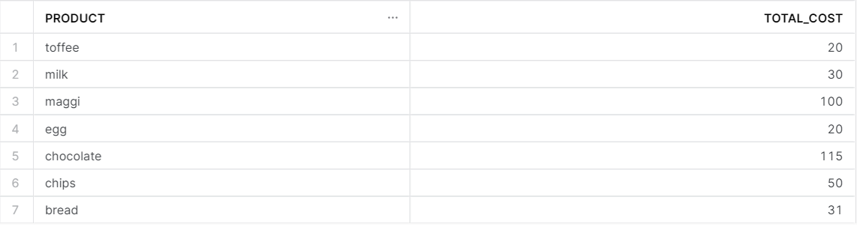

Task – 2

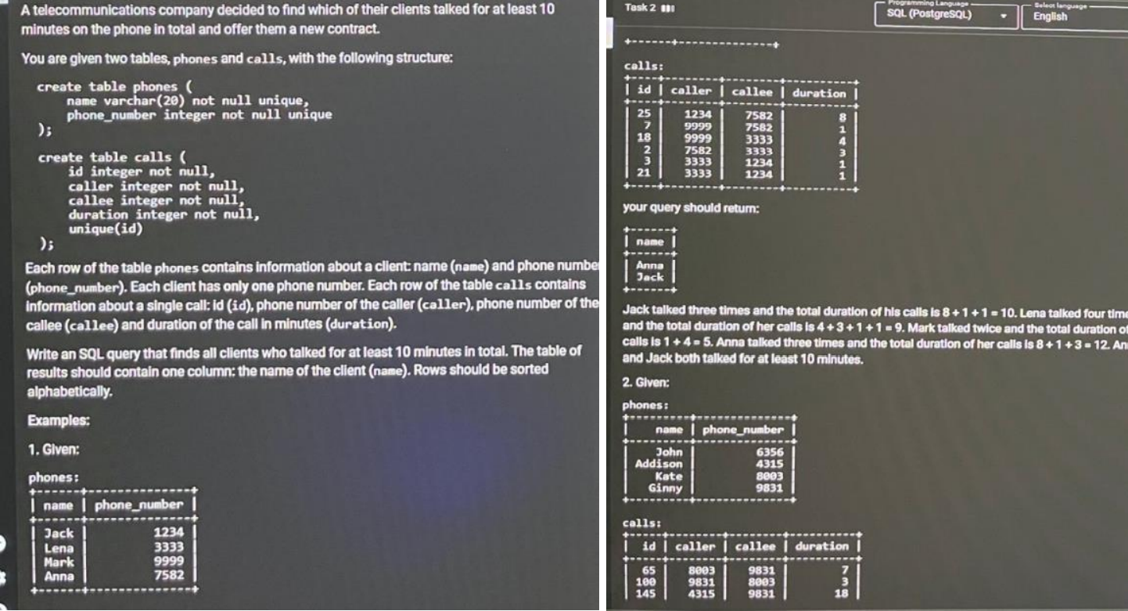

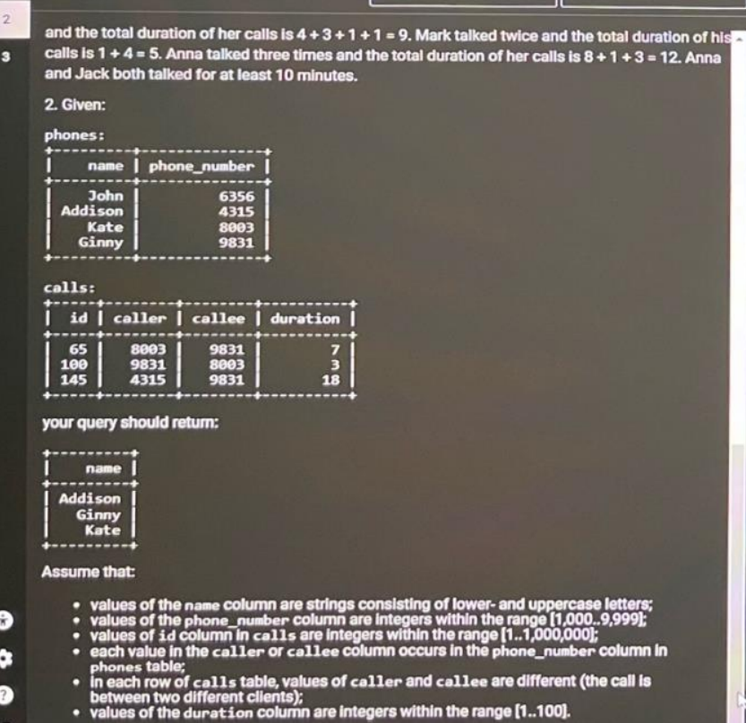

create table Phones (

Name Varchar(20) not null unique,

Phone_Number integer not null unique

);

Create table Calls (

ID integer not null,

caller integer not null,

Callee integer not null,

Duration integer not null,

Unique(ID)

);

Insert into Phones Values

('Jack' , 1234),

('Lena' , 3333),

('Mark' , 9999),

('Anna' , 7582),

('John' , 6356),

('Addison' , 4315),

('Kate' , 8003),

('Ginny' , 9831),

('Mike' , 6666),

('Stacy' , 3311);

Insert into Calls Values

(25,1234,7582,8),

(7,9999,7582,1),

(18,9999,3333,4),

(2,7582,3333,3),

(3,3333,1234,1),

(21,3333,1234,1),

(65,8003,9831,7),

(100,9821,8003,3),

(145,4315,9831,18),

(155,6666,3311,5);

**with call_duration as (**

**select caller as Phone_Number, Sum(Duration) as Duration from calls group by caller**

**Union all**

**select Callee as Phone_Number, Sum(Duration) as Duration from calls group by Callee**

**)**

**Select "NAME" from Phones p Join CALL_DURATION cd ON p.PHONE_NUMBER = cd.PHONE_NUMBER**

**group by 1**

**HAVING Sum(Duration) >= 10**

**ORDER by 1 ;**

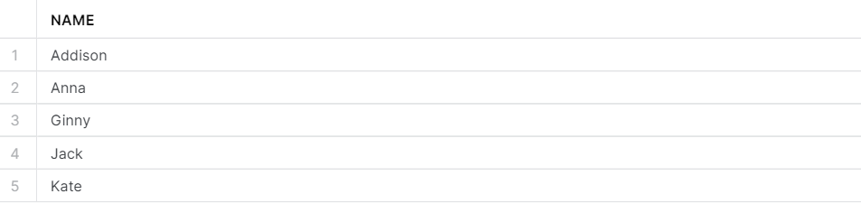

Task – 3Output display is just one column balance

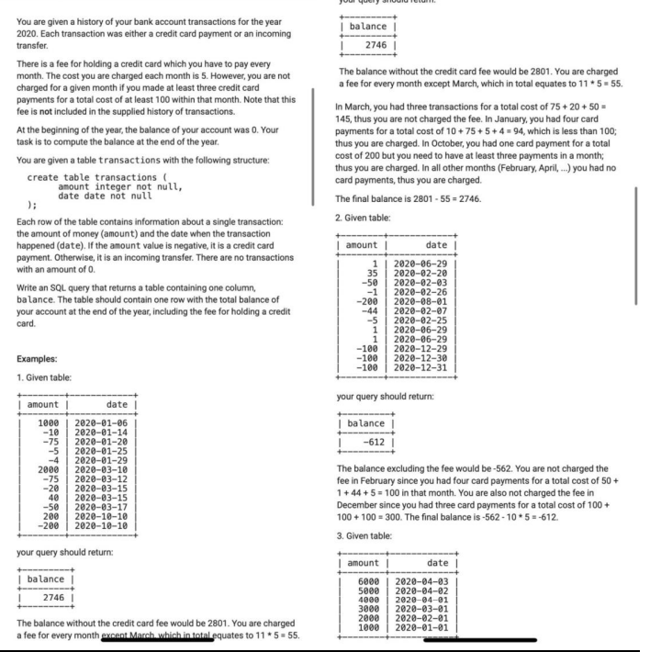

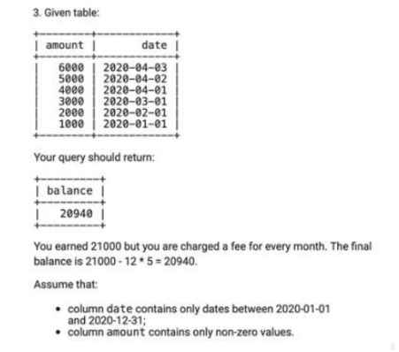

create table Transactions(

Amount Int NOT NULL,

`Date` Date NOT NULL

);

Insert into Transactions Values

(1000, '2020-01-06'),

(-10, '2020-01-14'),

(-75, '2020-01-20'),

(-5, '2020-01-25'),

(-4, '2020-01-29'),

(2000, '2020-03-10'),

(-75, '2020-03-12'),

(-20, '2020-03-15'),

(40, '2020-03-15'),

(-50, '2020-03-17'),

(200, '2020-10-10'),

(-200, '2020-10-10');

**Select ( sum(a.total) - (12- count(b.cnt ))*5 ) as result From**

**(Select sum(amount) as total , 'A' as name from transactions ) as a left join**

**(Select count(amount) as cnt , 'A' as name**

**From transactions**

**where amount <0**

**group by month("`DATE`")**

**having not(count(amount) <3 or sum(amount) >-100) ) as b**

**on a.name = b.name**

